- Your manager is interested in finding out if total sales by product type is impacted by market size? Please create a report showing that. Show it both as a table and as a chart. What type of chart you used? Why?
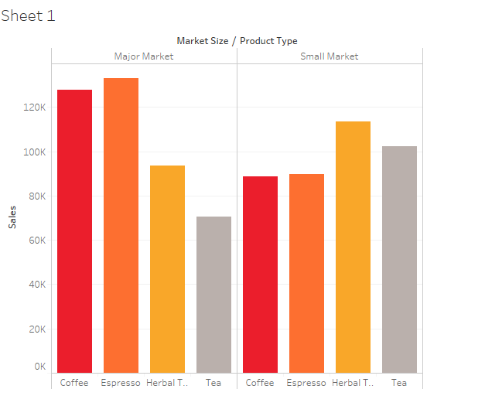

- Which product types are doing better in small markets vs large markets? Why do you think this is the case?

- How are the total sales related to total profit by product type? Which product type has the highest profit vs highest sales?

- Your boss is interested in California. Show the profit margin and profit by Product and Product type. In which product/type the company is losing money in?

- 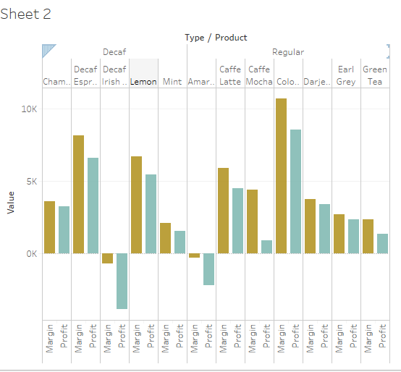

- Which Products are not available in decaf in California? Which products are only available in decaf (Type is the dimension for decaf and regular) 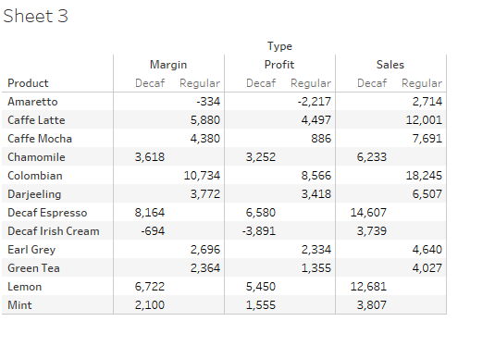

- Product manager responsible for coffee only is interested in sales of coffee across all the states? Which state has the highest coffee sales. Show it on a geo graph and a table. From the geo graph, can you identify the top 5 states for the highest coffee sales?

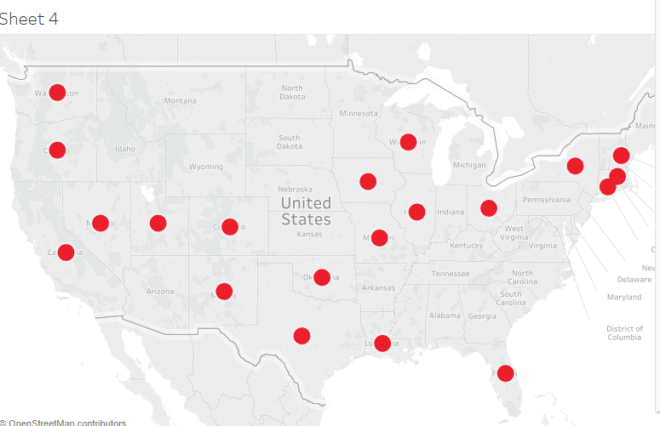

- Look at Profit by Regions (Market) by product group and Type. Can you identify a region with negative sales? Can you drill down and find out what is causing it? Find out which product and which state is causing negative sales?
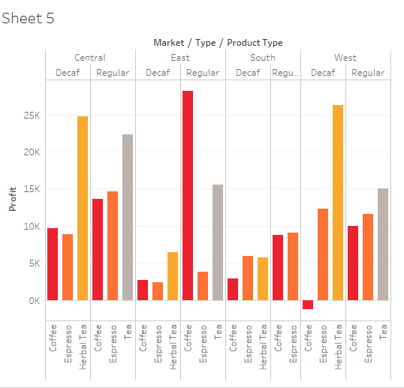

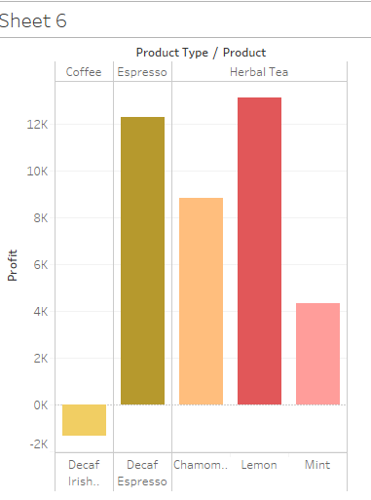

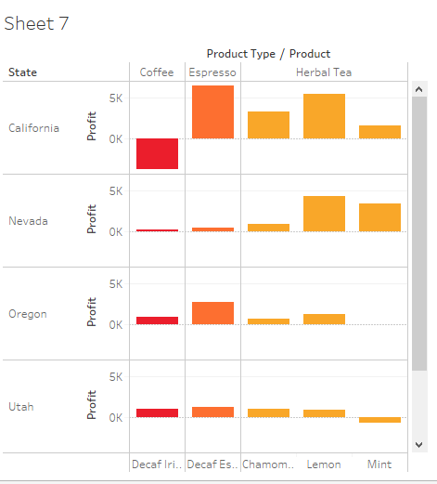

It was the decaf Irish Cream sales in Cali causing the loss. Other western states have positive profits

- Show the profits by quarter and by product type as a chart. For continuous type which type of graph is better? What is happening to the profit by product? Drill down and identify a cause for a decrease in a profit for a product(s). Identify a specific state and a specific product type that may be causing the decrease in revenue.

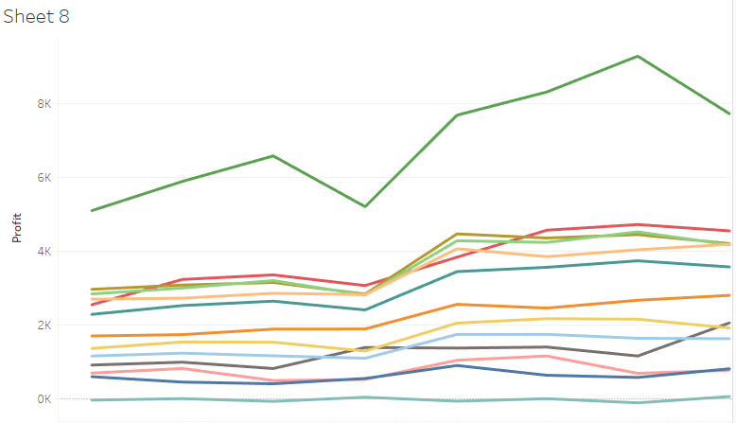
- Drill down and identify a fact that I have not mentioned above using tableau (show both table and graph)

